1. **Write a Python script to encrypt columnar transposition using keyword.**

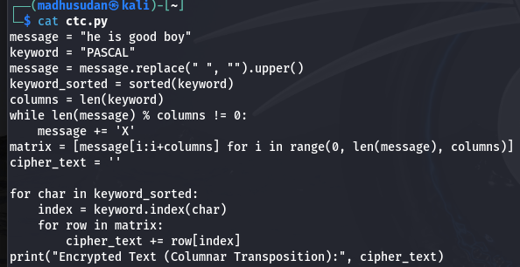

**Output**

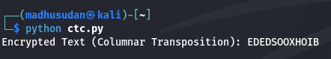

1. **Write a Python script to encrypt double columnar transposition.**

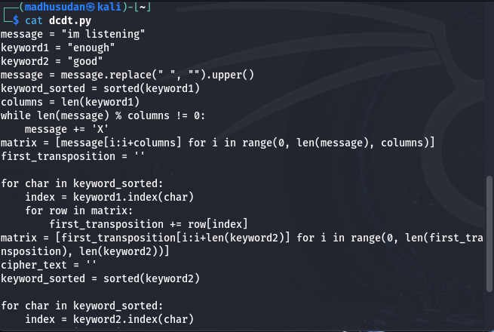

**Output**



1. **Write a Python script to encrypt the message “She is listening” using the 6-character keyword “PASCAL” with Vigenere cipher.**

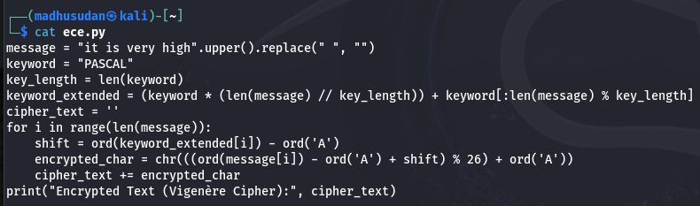

**Output**

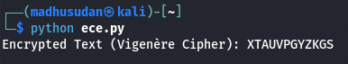

1. **Write a Python script to encrypt and decrypt Hill cipher**

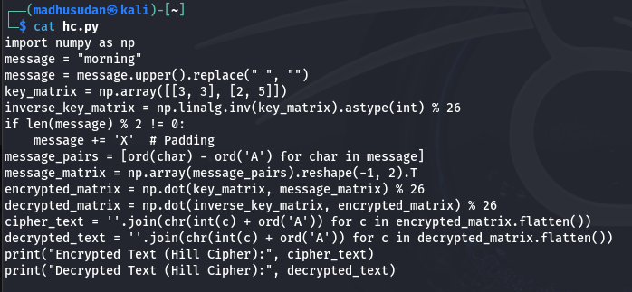

**Output**

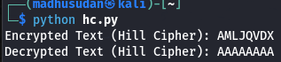

**Bonus Point:**

1. **Write a Python script to perform Kasiski test.**

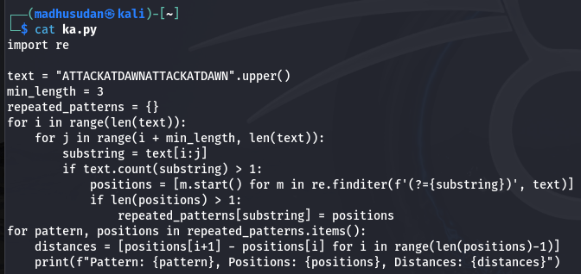

**Output**

